Anglo European School

Relationships and Sex Education (RSE) Policy



Approved by: | Full Governing Body
Date: | 9th July 2025
Review: | Annually
Statutory

Aims
The aims of relationships and sex education (RSE) at our school are to:
- Provide a framework in which sensitive discussions can take place
- Prepare students for puberty, and give them an understanding of sexual development and the importance of health and hygiene
- Help students develop feelings of self-respect, confidence and empathy
- Create a positive culture around issues of sexuality and relationships
- Teach students the correct vocabulary to describe themselves and their bodies
- To encourage the development of the Learner Profile attributes, including ‘knowledgeable’, ‘open-minded’, ‘kind’, ‘healthy’ and ‘reflective’

Statutory requirements
The school is secular, co-educational 11-19 comprehensive school with a diverse intake in terms of ethnicity, faith, nationality, language and culture. There is a very clear expectation that all members of the community will recognise that others, with their differences, can also be right.

As a secondary academy, we must provide RSE to all students under section 34 of the Children and Social Work Act 2017.
In teaching RSE, we’re required by our funding agreements to have regard to guidance issued by the secretary of state, as outlined in section 403 of the Education Act 1996.
We also have regard to legal duties set out in:
- Sections 406 and 407 of the Education Act 1996
- Part 6, chapter 1 of the Equality Act 2010
- The Public Sector Equality Duty (as set out in section 149 of the Equality Act 2010). This duty requires public bodies to have due regard to the need to eliminate discrimination, advance equality of opportunity and foster good relations between different people when carrying out their activities

At Anglo European School, we teach RSE as set out in this policy.
Policy development
This policy has been developed in consultation with staff, students and parents. The consultation and policy development process involved the following steps:
- Review – a member of staff or working group pulled together all relevant information including relevant national and local guidance

- Staff consultation – all school staff were given the opportunity to look at the policy and make recommendations

- Parent/stakeholder consultation – parents and any interested parties were invited to look at the policy and share feedback before publication.

- Student consultation – we investigated what exactly students want from their RSE through a Student Voice committee

- Ratification – once amendments were made, the policy was shared with governors and ratified

Definition
Where we refer to RSE, we often incorporate education around health as well. We will refer to this as RSHE.
RSHE is about the emotional, social and cultural development of students, and involves learning about relationships, sexual health, sexuality, healthy lifestyles, diversity and personal identity.
RSHE involves a combination of sharing information and exploring issues and values.
RSHE is not about the promotion of sexual activity.
Sex Education is defined as teaching children how human reproduction occurs, including how a baby is conceived. This draws on knowledge of the human life cycle set out in the national curriculum for science. For the purposes of this policy, we specifically identify any non-statutory Sex Education that falls outside of Science and those related elements (the physical changes associated with puberty) within statutory Health Education.

Curriculum
Our curriculum is set out as per Appendix 4 which will be adapted as and when necessary.
We have developed the curriculum in consultation with parents, students and staff, taking into account the age, needs and feelings of students. If students ask questions outside the scope of this policy, teachers will respond in an appropriate manner so they are fully informed. Our curriculum is regularly reviewed.

Delivery of RSE
RSE is taught within the Personal Citizenship element of our Citizenship Education programme. Biological aspects of RSE are taught within the science curriculum, and other aspects are included in Religious Studies (RS) and Computing.

RSE focuses on giving young people the information they need to help them develop healthy, nurturing relationships of all kinds including:
- Families
- Respectful relationships, including friendships
- Online and media
- Being safe
- Intimate and sexual relationships, including sexual health

These areas of learning are taught within the context of family life, taking care to make sure that there is no stigmatisation of children based on their home circumstances (families can include single parent families, LGBT parents, families headed by grandparents, adoptive parents and foster parents/carers, amongst other structures), along with reflecting sensitively that some children may have a different structure of support around them (for example, looked-after children or young carers).
We will also be mindful of the law and legal requirements, taking care not to condone or encourage illegal political activity, such as violent action against people, criminal damage to property, hate crime, terrorism or the illegal use of drugs.

Inclusivity
We will teach about these topics in a manner that:
- Considers how a diverse range of students will relate to them
- Is sensitive to all students’ experiences

During lessons, makes students feel:
- Safe and supported
- Able to engage with the key messages

We will also make sure that students learn about these topics in an environment that’s appropriate for them, for example in:
- A whole-class setting
- Small groups or targeted sessions
- 1-to-1 discussions
- Digital formats

We will give careful consideration to the level of differentiation needed.

Use of resources
We will consider whether any resources we plan to use:
- Are aligned with the teaching requirements set out in the statutory RSE guidance
- Would support students in applying their knowledge in different contexts and settings
- Are age-appropriate, given the age, developmental stage and background of our students
- Are evidence-based and contain robust facts and statistics
- Fit into our curriculum plan
- Are from credible sources
- Are compatible with effective teaching approaches
- Are sensitive to students’ experiences and won’t provoke distress

Use of external agencies and external materials
We will make sure that an agency and any materials used are appropriate and in line with our legal duties around political impartiality.
The school remains responsible for what is said to students. This includes making sure that any speakers, tools and resources used don’t undermine the fundamental British values of democracy, the rule of law, individual liberty, and mutual respect and tolerance of those with different faiths and beliefs.
We will make appropriate checks and engage with external agencies to make sure that their approach to teaching about RSE is balanced, and it and the resources they intend to use:
- Are age-appropriate
- Are in line with students’ developmental stage
- Comply with:
- This policy
- The Teachers’ Standards
- The Equality Act 2010
- The Human Rights Act 1998
- The Education Act 1996

We will only work with external agencies where we have full confidence in the agency, its approach and the resources it uses
We will make sure that any speakers and resources meet the intended outcome of the relevant part of the curriculum
We will review any case study materials and look for feedback from other people the agency has worked with
We will be clear on:
- what they’re going to say
- their position on the issues to be discussed
We will ask to see in advance any materials that the agency may use
We will know the named individuals who will be there, and follow our usual safeguarding procedures for these people
We will conduct a basic online search and address anything that may be of concern to us, or to parents and carers
We will check the agency’s protocol for taking pictures or using any personal data they might get from a session
We will remind teachers that they can say “no” or, in extreme cases, stop a session
We will make sure that the teacher is in the room during any sessions with external speakers
We won’t, under any circumstances:
- work with external agencies that take or promote extreme political positions
- use materials produced by such agencies, even if the material itself is not extreme
Roles and responsibilities
The Governing Body
The Governing Body will approve the RSE policy, and hold the Headteacher to account for its implementation.
The Governing Body will hold the Headteacher to account for the implementation of this policy.
The Headteacher
The Headteacher is responsible for ensuring that RSE is taught consistently across the school, and for managing requests to withdraw students from [non-statutory/non-science] components of RSE
Staff
Staff are responsible for:
- Delivering RSE in a sensitive way
- Modelling positive attitudes to RSE
- Monitoring progress
- Responding to the needs of individual students
- Responding appropriately to students whose parents wish them to be withdrawn from the [non-statutory/non-science] components of RSE
Staff do not have the right to opt out of teaching RSE. Staff who have concerns about teaching RSE are encouraged to discuss this with the Headteacher.
The Head of Citizenship, The Head of Science and the Designated Safeguarding Lead take responsibility for the delivery of RSE.
Students
Students are expected to engage fully in RSE and, when discussing issues related to RSE, treat others with respect and sensitivity.

Parents’ Right to Withdraw
Parents have the right to withdraw their children from the non-statutory/non-science components of sex education within RSE up to and until 3 terms before the child turns 16. After this point, if the child wishes to receive sex education rather than being withdrawn, the school will arrange this.
Requests for withdrawal should be put in writing using the form found in Appendix 3 of this policy and addressed to the Headteacher. Such requests will lead to a meeting with a Headteacher, where the following will be considered;

- The reasons for withdrawal.
- Any reasonable adjustments the school could make, short of withdrawal that would reassure the parents and/or the student.
- Whether the reasons for withdrawal raise any other concerns (e.g. safeguarding).
- Arrangements for completion of alternative work.
- The expectations the school has of any student who is withdrawn.
- Arrangements made by the parents to ensure their child’s understanding of relationships and sex continues to develop.
A copy of withdrawal requests will be placed in the student’s educational record.

Training

Staff are trained on the delivery of RSE as part of their induction and it is included in our continuing professional development calendar.
The Headteacher will also invite visitors from outside the school, such as school nurses or sexual health professionals, to provide support and training to staff teaching RSE.

Monitoring arrangements
The delivery of RSE is monitored by the Governing Body, the Headteacher, the Designated Safeguarding Lead and the Head of Citizenship through departmental reviews, learning walks, book looks and lesson observations. The school will also respond to positive comments from students and parents as well as any concerns or complaints that may be received.
Students’ development in RSE is monitored by class teachers as part of our internal assessment systems.
This policy will be reviewed annually or as and when necessary.

Appendix 1: AES Mission Statement
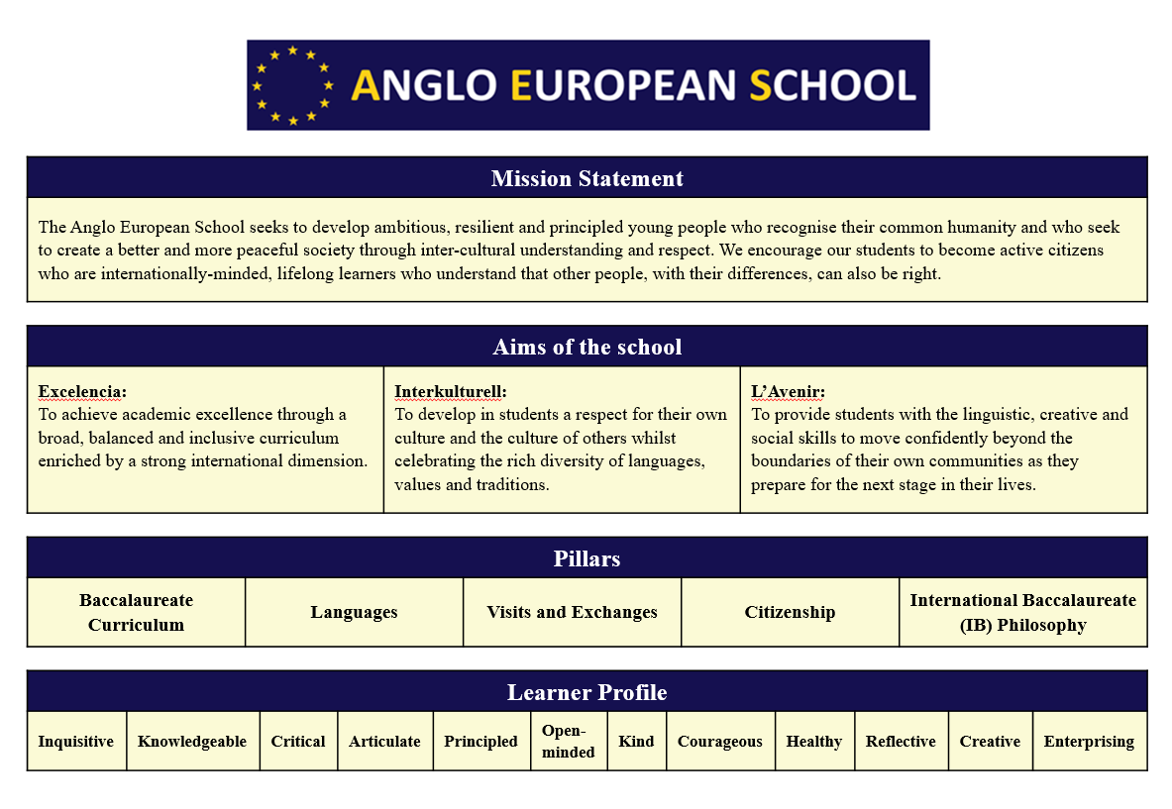
As learners we all strive to be:

Inquisitive: We nurture our curiosity, developing skills for inquiry and research. We know how to learn independently and with others. We learn with enthusiasm and sustain our love of learning throughout life.

Knowledgeable: We develop and use conceptual understanding across a range of disciplines. We engage with issues and ideas that have local and global significance.

Critical: We are thinkers. We use critical and creative thinking skills to analyse and take responsible action on complex problems. We exercise initiative in making reasoned, ethical decisions.

Articulate: We are good communicators. We express ourselves confidently and creatively in more than one language and in many ways. We collaborate effectively, listening carefully to the perspectives of other individuals and groups.

Principled: We act with integrity and honesty, with a strong sense of fairness and justice, and with respect for the dignity and rights of people everywhere. We take responsibility for our actions and their consequences.

Open-minded: We critically appreciate our own cultures and personal histories, as well as the values and traditions of others. We seek and evaluate a range of points of view, and we are willing to grow from the experience.

Kind: We are caring. We show empathy, compassion and respect. We have a commitment to service, and we act to make a positive difference in the lives of others and in the world around us. We are calm and considerate.

Courageous: We are risk-takers. We approach uncertainty with forethought and determination; we work independently and cooperatively to explore new ideas and innovative strategies. We are resourceful and resilient in the face of challenges and change.

Healthy: We are balanced. We understand the importance of balancing different aspects of our lives – intellectual, physical, and emotional – to achieve well-being for ourselves and others. We recognise our interdependence with other people and with the world in which we live.

Reflective: We thoughtfully consider the world and our own ideas and experience. We work to understand our strengths and weaknesses in order to support our learning and personal development.

Creative: We express ourselves in a variety of ways and feel comfortable in doing so. We approach problems and challenges with an open mind. We like to be different and face our fears.

Enterprising: We enjoy working with people towards common goals. We show confidence and enthusiasm and are prepared to make thoughtful decisions.

We believe these attributes, and others like them, can help individuals and groups become responsible members of local, national and global communities. This Learner Profile is closely modelled on the Learner Profile of the International Baccalaureate Organisation.

Appendix 2: By the end of secondary school students should know (from the statutory guidance)
Topic | Students should know
Families | - That there are different types of committed, stable relationships  - How these relationships might contribute to human happiness and their importance for bringing up children  - What marriage is, including their legal status e.g. that marriage carries legal rights and protections not available to couples who are cohabiting or who have married, for example, in an unregistered religious ceremony  - Why marriage is an important relationship choice for many couples and why it must be freely entered into  - The characteristics and legal status of other types of long-term relationships  - The roles and responsibilities of parents with respect to raising of children, including the characteristics of successful parenting  - How to determine whether other children, adults or sources of information are trustworthy: judge when a family, friend, intimate or other relationship is unsafe (and to recognise this in others’ relationships); and, how to seek help or advice, including reporting concerns about others, if needed
Respectful relationships, including friendships | - The characteristics of positive and healthy friendships (in all contexts, including online) including: trust, respect, honesty, kindness, generosity, boundaries, privacy, consent and the management of conflict, reconciliation and ending relationships. This includes different (non-sexual) types of relationship  - Practical steps they can take in a range of different contexts to improve or support respectful relationships  - How stereotypes, in particular stereotypes based on sex, gender, race, religion, sexual orientation or disability, can cause damage (e.g. how they might normalise non-consensual behaviour or encourage prejudice)  - That in school and in wider society they can expect to be treated with respect by others, and that in turn they should show due respect to others, including people in positions of authority and due tolerance of other people’s beliefs  - About different types of bullying (including cyberbullying), the impact of bullying, responsibilities of bystanders to report bullying and how and where to get help  - That some types of behaviour within relationships are criminal, including violent behaviour and coercive control  - What constitutes sexual harassment and sexual violence and why these are always unacceptable  - The legal rights and responsibilities regarding equality (particularly with reference to the protected characteristics as defined in the Equality Act 2010) and that everyone is unique and equal
Online and media | - Their rights, responsibilities and opportunities online, including that the same expectations of behaviour apply in all contexts, including online  - About online risks, including that any material someone provides to another has the potential to be shared online and the difficulty of removing potentially compromising material placed online  - Not to provide material to others that they would not want shared further and not to share personal material which is sent to them  - What to do and where to get support to report material or manage issues online  - The impact of viewing harmful content  - That specifically sexually explicit material e.g. pornography presents a distorted picture of sexual behaviours, can damage the way people see themselves in relation to others and negatively affect how they behave towards sexual partners  - That sharing and viewing indecent images of children (including those created by children) is a criminal offence which carries severe penalties including jail sentences  - How information and data is generated, collected, shared and used online
Being safe | - The concepts of, and laws relating to, sexual consent, sexual exploitation, abuse, grooming, coercion, harassment, rape, domestic abuse, forced marriage, honour-based violence and FGM, and how these can affect current and future relationships  - How people can actively communicate and recognise consent from others, including sexual consent, and how and when consent can be withdrawn (in all contexts, including online)
Intimate and sexual relationships, including sexual health | - How to recognise the characteristics and positive aspects of healthy one-to-one intimate relationships, which include mutual respect, consent, loyalty, trust, shared interests and outlook, sex and friendship  - That all aspects of health can be affected by choices they make in sex and relationships, positively or negatively, e.g. physical, emotional, mental, sexual and reproductive health and wellbeing  - The facts about reproductive health, including fertility and the potential impact of lifestyle on fertility for men and women  - That there are a range of strategies for identifying and managing sexual pressure, including understanding peer pressure, resisting pressure and not pressurising others  - That they have a choice to delay sex or to enjoy intimacy without sex  - The facts about the full range of contraceptive choices, efficacy and options available  - The facts around pregnancy including miscarriage  - That there are choices in relation to pregnancy (with medically and legally accurate, impartial information on all options, including keeping the baby, adoption, abortion and where to get further help)  - How the different sexually transmitted infections (STIs), including HIV/AIDs, are transmitted, how risk can be reduced through safer sex (including through condom use) and the importance of and facts about testing  - About the prevalence of some STIs, the impact they can have on those who contract them and key facts about treatment  - How the use of alcohol and drugs can lead to risky sexual behaviour  - How to get further advice, including how and where to access confidential sexual and reproductive health advice and treatment

Appendix 3: Parent Form: Withdrawal from sex education within RSE

To be completed by parents
Name of student |  |  | Tutor Group
Name of parent/ carer |  |  | Date
Reason for withdrawing from Sex Education within Relationships and Sex Education (RSE). Please note there is no statutory right to withdraw from any aspect of Relationships Education.
Please include arrangements you intend to make for alternative study

Any other information you would like the school to consider
Parent’s/Carer’s signature
To be completed by the school
Agreed actions from discussion between Headteacher and parent/carer
Date implemented:
Monitored by:
Date of Review:

APPENDIX 4: List of planned themes taught as part of the School’s RSE programme by subject.
In Citizenship:
Year 7:
- Friendships
- Bullying
- Children’s rights
- Relationships with parents
- Romantic relationships (including different types of relationships/LGB)
- Legal status of relationships (marriage/civil partnerships etc)
- Trustworthiness of relationships
- Traits of positive and strong relationships
- Body changes: puberty

Year 8:
- Peer pressure/influence
- Crime and Safety Awareness Day (includes sexting and the law, exploitation and honour-based abuse)
- Diversity in the UK
- Prejudice and stereotypes
- Discrimination and persecution
- Recognising radicalisation and extremism (linked to Prevent)

Year 9:
- Conflict resolution theory
- Personal conflicts
- Internet safety and online grooming
- Social media: safe and private
- Sex in the media: pornography and its impact
- Biology of reproduction
- LGBTQ relationships
- Consent in romantic/sexual relationships
- Sexually transmitted infections (STIs) and how to avoid
- Pregnancy (including birth control)
- Relationship abuse
- Sharing sexual images: Impact and the law
- Cyber bullying
- Self-esteem and body image
- Child exploitation and trafficking

Key Stage 4 (core and GCSE cohorts)
- Bullying, prejudice, discrimination and behavior in the workplace
- Relationships and sex
- Marriage and civil partnerships
- Parenting
- Gangs
- Abusive relationships
- Forced marriage, FGM and honour-based abuse
- Harassment and social media
- Sex in the media (including pornography)
- Consent
- Sexually transmitted infections and prevention
- Fertility
- Abortion and pregnancy options (fostering/adoption)
- Body image
- Identity in the UK (including gender, sexual orientation, religion and ethnicity) Equality Act 2010
- Development and recapping of key topics from Years 7-9

Sixth Form:
- Healthy relationships, consent, pressure and expectations
- Harmful relationships
- Sex and the media
- Risks associated with parties, clubbing and festivals
- Workplace relationships
- GDPR and online safety/security

In Science
Key Stage 3:
- The facts around pregnancy and human reproduction
- Implantation
- development of the foetus
- birth
- Puberty

Key Stage 4:
- The facts about the full range of contraceptive choices
- Hormonal and non-hormonal methods of contraception and how they work. Evaluation of methods of contraception.
- How the different sexually transmitted infections (STIs), including HIV/AIDs, are transmitted, how risk can be reduced through safer sex (including through condom use)
- How HIV is spread, how it attacks the body and how it progresses to late stage HIV infection or AIDS. How gonorrhoea is spread, its treatment and how it can be controlled.

In Religious Studies:
Key Stage 3:
- Marriage as a rite of passage
- Respectful relationships (religious discrimination)

Key Stage 4 (GCSE students only):
- Religious and secular views of sex and sexuality
- Religious and secular views on sexual orientation
- Religious and secular views on gender and gender identity
- Religious and secular views on families
- Religious and secular views on marriage and cohabitation

Computing:
Key Stage 3:
- Social media safety, grooming/harm, age restrictions
- Privacy and data protection
- Cyber bullying

