
SEND Information Booklet 2025-2026
An Information Guide for Parents and Carers
Our practice is guided by the revised 2015 SEND Code of Practice. We seek to support SEND students to reach their full academic potential in terms of qualifications, develop ambitious, resilient and principled young people who recognise their common humanity and who seek to create a better and more peaceful society through inter-cultural understanding and respect. We encourage and support our SEND students, through reasonable adjustments according to their needs, to become active citizens who are internationally-minded, lifelong learners who understand that they and other people, with their differences, can also be right.
What is the SEND Code of Practice?
The SEND Code of Practice is a national document which all schools must refer to when making decisions relating to provision for students with Special Educational Needs and Disabilities (SEND). This helps to ensure that children have access to a similar system of support, whichever school they attend.
What are Special Educational Needs?
A child may have a Special Educational Needs and Disabilities (SEND) if they require additional and different provision to support them in their learning, in order to ensure that they make expected progress in line with their peers.
The Code of Practice says: ‘A child or young person has SEND if they have a challenge or disability which calls for additional and different special educational provision to be made.
A child of school age has a SEND need if he or she:
● has a significantly greater difficulty in learning than the majority of the same age in local schools, or
● has a disability which prevents or hinders him or her from making use of facilities of a kind generally provided for others of the same age.
There are four broad areas of SEND need. These are:
● Communication and Interaction
● Cognition and Learning
● Social, Emotional and Mental Health
● Sensory and/or Physical Needs
What are our values and expectations regarding students with SEND needs?
At our school, there is a shared expectation that responsibility for the provision of students with SEND is an integral part of whole school provision. All students to address and make adaptations for their SEND needs, will receive adapted and inclusive teaching, which will enable them to make the best possible progress and feel that they are valued members of the wider school community.
What does the school do to help/ What is SEND support?
As a school, we assess all children to identify their strengths and needs to determine how they can best be supported. All children learn and develop in different ways and their needs may change over time. Teachers recognise this and use different teaching styles, resources and plan different levels of work in the classroom to cater for the various ways children learn. This is Adaptive Teaching and is something schools must provide for all children.
At Anglo European School, support is offered in a graduated approach, taking the form of a four-part cycle:
● Assess
● Plan
● Do
● Review.

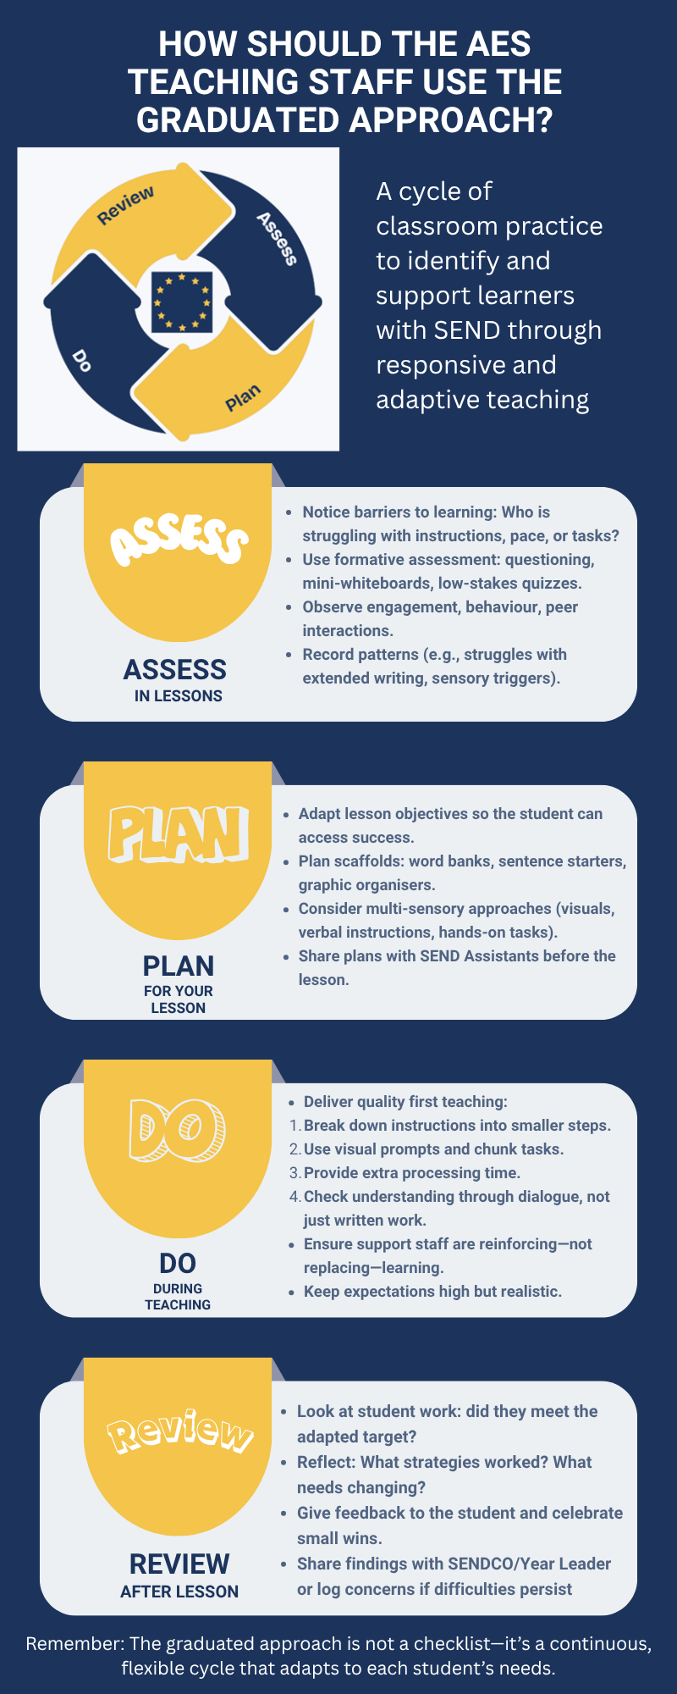
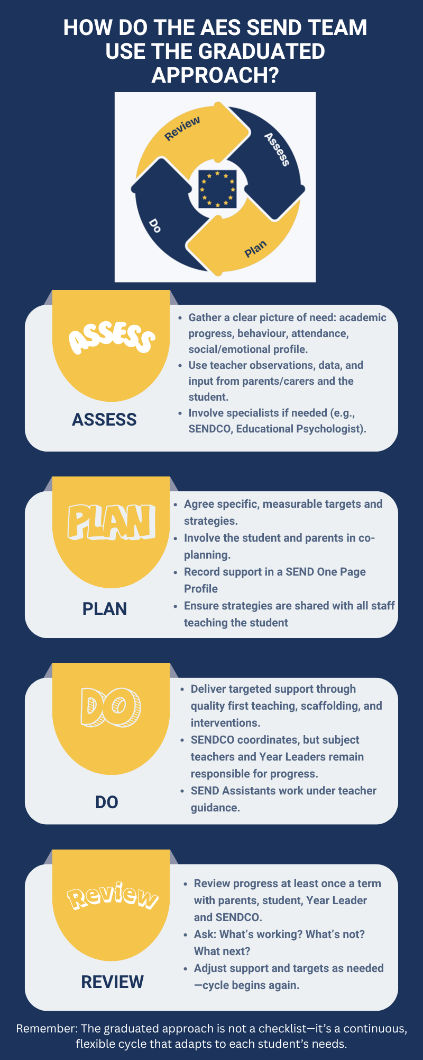

We recognise that high quality adaptive teaching, tailored to individual students, is the first step in responding to students who have or may have SEND. These adaptations may involve modifying learning objectives, making changes to live teaching strategies and work and working collaboratively with parents or carers.
If, following appropriate teacher assessments and support, a child does not make satisfactory progress, the class teacher will make a referral to the HOD/HOS/YL.
If departmental specialist support does not yield progress then again HOD/ HOS will make contact with parents and referral to the year leader and SENDCO will be made, who may carry out assessments and observations and then suggest next steps and additional ways in which the student can be supported.
Many children (Wave 2) may receive support or help in class through work, which matches the way they learn and / or short-term interventions. Some children (Wave 3) will have extra help, on a longer-term basis, from members of school staff in order to accelerate progress and ensure they achieve the targets they have been set. They will be placed on the school’s SEND/Inclusion register and targets will be set, monitored and reviewed as part of a review cycle. A proportion of children (still Wave 3) may benefit from support and advice from other sources and specialists. They will have an individual targeted SEN support plan. A minority of children (Wave 4) will have exceptional long term and complex needs and will require an EHCP.

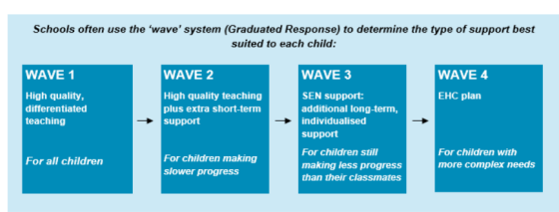
A robust transition system and team in place.
The primary schools and parents are asked to fill in and return a form about their students/children’s needs and current provisions. During the summer term, the Year Leader and the SENDCo will visit our local primary schools to ensure all the updated information is gathered and shared with teachers to inform the Induction Days. We organise two days of transition and the SEND Department organises three visits prior to the two induction days to prepare students with SEND for the Induction Days and the SENDCo meets parents of students with SEND during those visits if they attend to answer any question, not already answered on our website/ parental information leaflet or SEND videos.
What is SEND support?
To support SEND children, we look at the individual child’s barriers to learning and put the appropriate provision in place to remove those barriers. SEND support might include:
● Extra adult support in classrooms, where appropriate
● Adapting and utilising different teaching styles
● Adapting resources to ensure they are accessible
● Small group or one-to-one learning, both within the class and as interventions
● Using recommended aids, such as laptops, larger font, etc.
- Access arrangements for tests and examinations
● Support from specialists: visual and hearing impairment specialist teachers, Educational Psychologist, and provision of specialist equipment for students.
Progress towards the targets set is monitored closely and adjustments to provision is made, as and when needed.

Who may become involved with my child from outside the school?
Experts from outside agencies may be asked to assess your child’s needs if, despite the support put into place, their progress is slow, and they continue to have difficulties. These assessments are generally focused on giving the school and parents/carers additional advice on the best way to support the child, rather than on giving a ‘diagnosis’. The SENDCo will ask for your permission to seek additional advice from outside specialists such as health professionals, specialist teachers or an educational psychologist who would:
- Carry out further assessment of your child’s needs
- Observe your child
- Provide advice to the school on how best to support your child
- Suggest resources that would help your child to make progress Parents/Carers are, wherever possible, offered the opportunity to meet with these professionals to discuss the results of their assessments / observations

Does the school get individual funding for my child’s SEND needs?
Unless a child has an EHC plan, the school does not receive specific funding for individuals, rather, part of the school’s budget is for supporting students with special educational needs and disabilities. The amount each school receives is based on the number and age of students attending; this is known as ‘per pupil entitlement.’ An additional Notional SEND budget provides funding to offer extra support to students with additional needs, including those with SEND. The value of funding each school receives varies and is informed by a set of government indicators. A child with an EHC plan is allocated a set amount of ‘top up funding’ and this is used to give the provision outlined in their individual plan.
Who do I talk to?
We always recommend that you speak to your child's pastoral tutor or Year Leader first. This is because they know your child almost as well as you do! If needed, they will signpost you to the SEND team. If you need to speak to a member of the school’s, SEND team, please either call the school office to arrange an appointment or email the enquires email address.
The school SEND team will always do all they can to respond to your concerns and will work in partnership with you and external agencies to ensure that we meet in a timely manner to discuss any issues. Immediate responses are not always possible due to teaching commitments and limited availability but please be reassured that we are working as hard as we can to ensure we can support all children and all families in our care.
How can I help my child?
Research shows that children who make the greatest progress are those whose parents support the work carried out at school by:
- Making sure school knows about any major changes in your family or sharing your worries with us.
- Encouraging your child with reading, spelling and home learning.
- Continual encouragement and praise to keep your child motivated.
- Attending all meetings such as Information and Parent Evenings and arranging meetings with the SENDCO if you have concerns. We will achieve the best results for your child if we work together.

